GCC Compilation Process

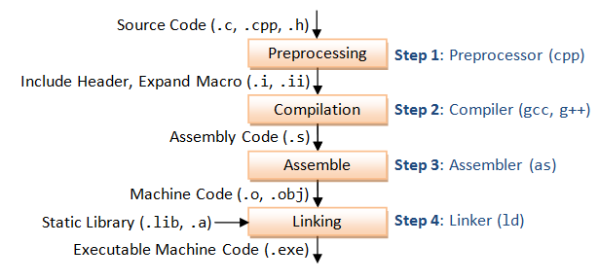

GCC compiles a C/C++ program into executable in 4 steps as shown in the above diagram. For example, a "gcc -o hello.exe hello.c" is carried out as follows:
- Pre-processing: via the GNU C Preprocessor (cpp.exe), which includes the headers (#include) and expands the macros (#define).
> cpp hello.c > hello.i
The resultant intermediate file "hello.i" contains the expanded source code.
- Compilation: The compiler compiles the pre-processed source code into assembly code for a specific processor.
> gcc -S hello.i
The -S option specifies to produce assembly code, instead of object code. The resultant assembly file is "hello.s".
- Assembly: The assembler (as.exe) converts the assembly code into machine code in the object file "hello.o".
> as -o hello.o hello.s
- Linker: Finally, the linker (ld.exe) links the object code with the library code to produce an executable file "hello.exe".
> ld -o hello.exe hello.o ...libraries...

Verbose Mode (-v)
You can see the detailed compilation process by enabling -v (verbose) option. For example,
> gcc -v -o hello.exe hello.c

Defining Macro (-D)
You can use the -Dname option to define a macro, or -Dname=value to define a macro with a value. The value should be enclosed in double quotes if it contains spaces.

1.8 Headers (.h), Static Libraries (.lib, .a) and Shared Library (.dll, .so)

Static Library vs. Shared Library
A library is a collection of pre-compiled object files that can be linked into your programs via the linker. Examples are the system functions such as printf() and sqrt().
There are two types of external libraries: static library and shared library.
- A static library has file extension of ".a" (archive file) in Unixes or ".lib" (library) in Windows. When your program is linked against a static library, the machine code of external functions used in your program is copied into the executable. A static library can be created via the archive program "ar.exe".
- A shared library has file extension of ".so" (shared objects) in Unixes or ".dll" (dynamic link library) in Windows. When your program is linked against a shared library, only a small table is created in the executable. Before the executable starts running, the operating system loads the machine code needed for the external functions - a process known as dynamic linking. Dynamic linking makes executable files smaller and saves disk space, because one copy of a library can be shared between multiple programs. Furthermore, most operating systems allows one copy of a shared library in memory to be used by all running programs, thus, saving memory. The shared library codes can be upgraded without the need to recompile your program.
Because of the advantage of dynamic linking, GCC, by default, links to the shared library if it is available.
You can list the contents of a library via "nm filename".

Searching for Header Files and Libraries (-I, -L and -l)
When compiling the program, the compiler needs the header files to compile the source codes; the linker needs the libraries to resolve external references from other object files or libraries. The compiler and linker will not find the headers/libraries unless you set the appropriate options, which is not obvious for first-time user.
For each of the headers used in your source (via #include directives), the compiler searches the so-called include-paths for these headers. The include-paths are specified via -Idir option (or environment variable CPATH). Since the header's filename is known (e.g., iostream.h, stdio.h), the compiler only needs the directories.
The linker searches the so-called library-paths for libraries needed to link the program into an executable. The library-path is specified via -Ldir option (uppercase 'L' followed by the directory path) (or environment variable LIBRARY_PATH). In addition, you also have to specify the library name. In Unixes, the library libxxx.a is specified via -lxxx option (lowercase letter 'l', without the prefix "lib" and ".a" extension). In Windows, provide the full name such as -lxxx.lib. The linker needs to know both the directories as well as the library names. Hence, two options need to be specified.

Default Include-paths, Library-paths and Libraries
Try list the default include-paths in your system used by the "GNU C Preprocessor" via "cpp -v":
> cpp -v
......
#include "..." search starts here:
#include <...> search starts here:
/usr/lib/gcc/x86_64-pc-cygwin/6.4.0/include
/usr/include
/usr/lib/gcc/x86_64-pc-cygwin/6.4.0/../../../../lib/../include/w32api
Try running the compilation in verbose mode (-v) to study the library-paths (-L) and libraries (-l) used in your system:
> gcc -v -o hello.exe hello.c
......
-L/usr/lib/gcc/x86_64-pc-cygwin/6.4.0
-L/usr/x86_64-pc-cygwin/lib
-L/usr/lib
-L/lib
-lgcc_s // libgcc_s.a
-lgcc // libgcc.a
-lcygwin // libcygwin.a
-ladvapi32 // libadvapi32.a
-lshell32 // libshell32.a
-luser32 // libuser32.a
-lkernel32 // libkernel32.a

